1. Fetch date and temperature from temperature_data where zip code is greater than 300000 and less than 399999.

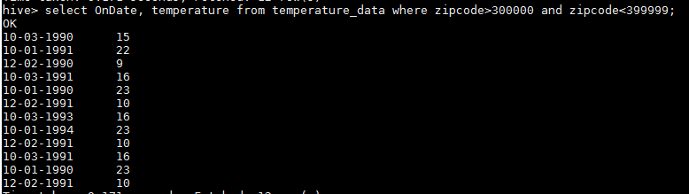

1. Calculate maximum temperature corresponding to every year from temperature_data table.

select MAX(temperature),SUBSTR(ondate,7,4) from temperature_data group by SUBSTR(ondate,7,4);

--7 is the index (starting from 1) and 4 is the length.

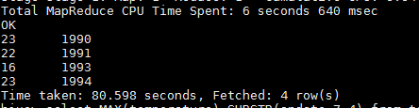

1. Calculate maximum temperature from temperature_data table corresponding to those years which have at least 2 entries in the table.

select MAX(temperature),SUBSTR(ondate,7,4) from temperature_data group by SUBSTR(ondate,7,4) having COUNT(SUBSTR(ondate,7,4))>2;

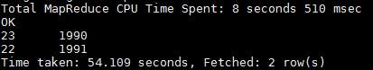

1. Create a view on the top of last query, name it temperature_data_vw.

create view temperature_data_vw as select MAX(temperature) as maxtemp,SUBSTR(ondate,7,4) as year from temperature_data group by SUBSTR(ondate,7,4) having COUNT(SUBSTR(ondate,7,4))>2;

select * from temperature_data_vw;

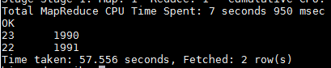

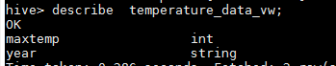

1. Export contents from temperature_data_vw to a file in local file system, such that each file is '|' delimited.

insert overwrite local directory '/home/acadgild/nikidir/s14/'

row format delimited

fields terminated by '|' select * from temperature_data_vw;

